**Lab 6 – SQL**

**Each problem is worth one point. No partial credit will be given. This lab is worth a total of 15 points.**

**From this lab forward, please notice if a result table is in a particular order. If it is you must use the order by clause. Failure to do so will result in 0 points for that specific problem.**

**Place all answers into ONE .sql file and upload to Canvas.**

**Table names are not given. You must determine the correct tables.**

**\*\*\*\* Use the Student table space for the following questions \*\*\*\***

**1. Display the average course fee.**



**2. Display the student’s state. You must use the explicit join format. Show only first 10 rows.**

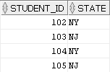

**3. Display the student’s state. You must use the implicit join format. Show only first 10 rows.**



**4. Display the student’s city and state. You must use the explicit join format. Show only first 10 rows.**

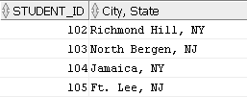

**\*\*\* Use EXPLICIT format whenever joining tables for all remaining problems \*\*\***

**5. Display the following result table.**

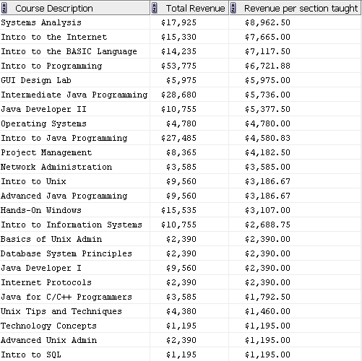

**6. Create the following result table.**

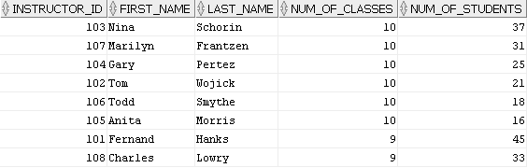

**7. What is the average numeric grade for all grade types? Display the following result table.**

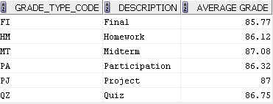

**8. Create the following result table.**

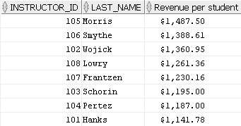

**\*\*\*\* Use the AP table space for the following questions \*\*\*\***

**9. Display the vendor name for all invoices. Fetch first 10 rows only.**

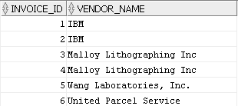

**10. Display all the different vendor names as per the following result table. Fetch first 20 rows only.**

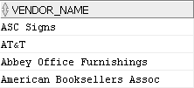

**11. Display the vendor name for all invoices. Only include the vendors whose names are between**

**the letters ‘H’ and ‘M’ inclusive.**

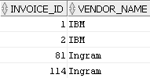

**12. Display the earliest and latest payment dates for all non-null invoices. In addition, use the average**

**number of days difference between these two dates to calculate a new date that is exactly**

**between the earliest and latest payment dates as per the result table.**



**13. Remove the dashes from the invoice number. Show first 20 rows only.**

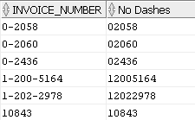

**14. Display all vendor names that end in either Inc (no period) or Inc. (with a period). In addition, the**

**query must eliminate any vendor names that may start with Inc (no period).**

**Partial result table (15 rows total)**

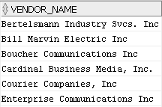

**15. Display each vendor’s complete address for those vendors that start with a ‘P’. Pay attention to the address for Pacific Bell. Notice there are no spaces before this address.**

